[Skip to end of metadata](https://confluence.fg.rbc.com/display/IMAI/IBM+UrbanCode+Deploy+%28UCD%29+Configuration" \l "page-metadata-end)

* Created by [Somov, Mykola (CWM-NR)](https://confluence.fg.rbc.com/display/~mysomov), last modified on [Jan 03, 2018](https://confluence.fg.rbc.com/pages/diffpagesbyversion.action?pageId=308018306&selectedPageVersions=8&selectedPageVersions=9)

[Go to start of metadata](https://confluence.fg.rbc.com/display/IMAI/IBM+UrbanCode+Deploy+%28UCD%29+Configuration#page-metadata-start)

Overview

UCD is an automated deployment suite that can be used to prep and deploy build artifacts. It is most easily used and triggered from Jenkins (see: [here](https://confluence.fg.rbc.com/display/IMAI/Jenkins+Configuration)), and can be easily used for the software promotion process.

Getting Started

To begin with you need to confirm your environment has UCD agents installed. For this contact Environment Management team: +T&O-E&IA-RBCCM Risk IT-Environment Mgmt <T&OE&I[ARBCCMRiskITEnvironmentMgmt@rbc.com](mailto:ARBCCMRiskITEnvironmentMgmt@rbc.com)> and ask them to install UCD agents on all your machines.

Next raise a MyMarketPlace ([https://rbc.service-now.com//myMarketPlace/#!/](https://rbc.service-now.com/myMarketPlace/#!/)) request to be added to the following ad groups:

APP_RCL0_<APP_CODE_HERE>_DEVELOPER_LEAD   ------------ lets you edit applications

APP_RCL0_<APP_CODE_HERE>_DEVELOPER              ------------ lets you launch applications

Once installed go to: [**https://rbcucd.fg.rbc.com:8443/**](https://rbcucd.fg.rbc.com:8443/)and log in with your LAN ID.

Now under the applications tab you should be able to see all the applications you are registered under:

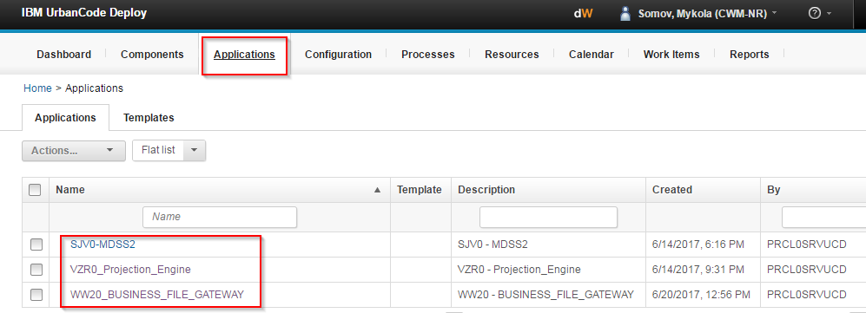

Click an application name and you should see the following:

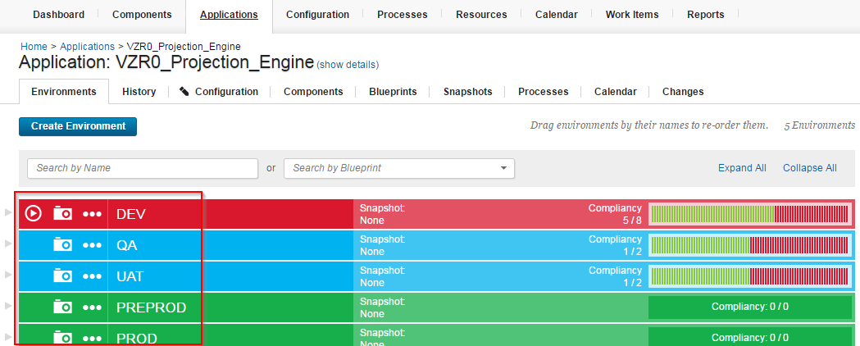

If you confirm the following screen with different types of environments UCD has been installed on your machines properly.

Running UCD Manually

If you ever want to deploy a UCD build manually simply do the following:

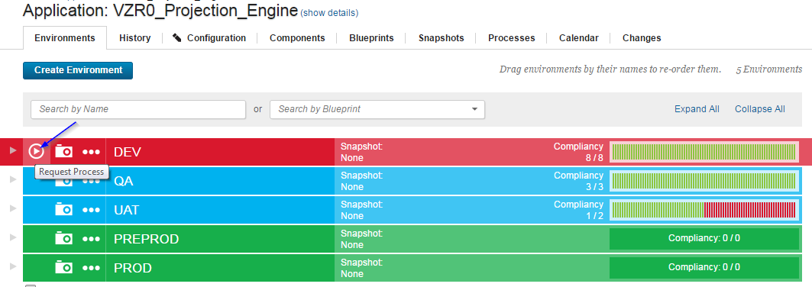

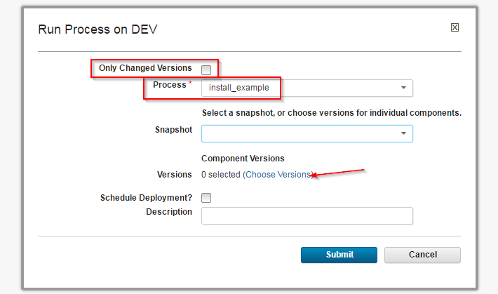

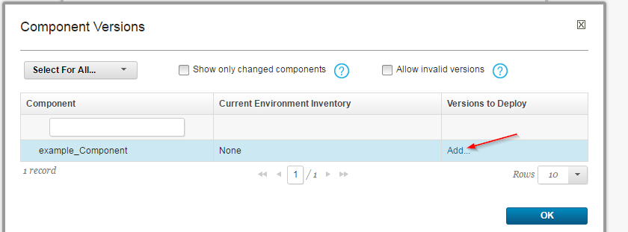

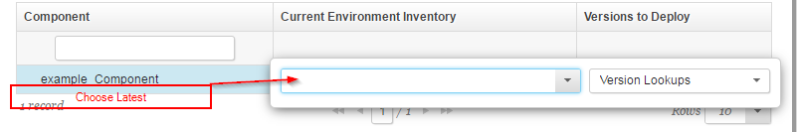

Configuration

To compose a UCD process for an application:

1. Go to components and create a new component
2. In your new component, go to processes and build a deployment process
3. Add your component to your application
4. Add a process to your application to install your component
5. Go to your application, and under all your target environments, add your component
6. Add a post build action to your Jenkins, to trigger your Component

Detailed instructions follow:

**1) Go to components and create a new component**

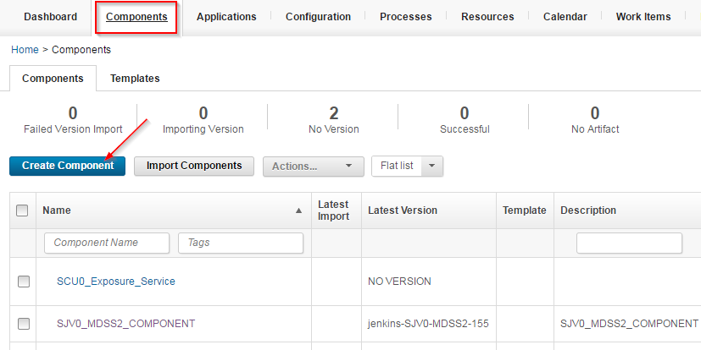

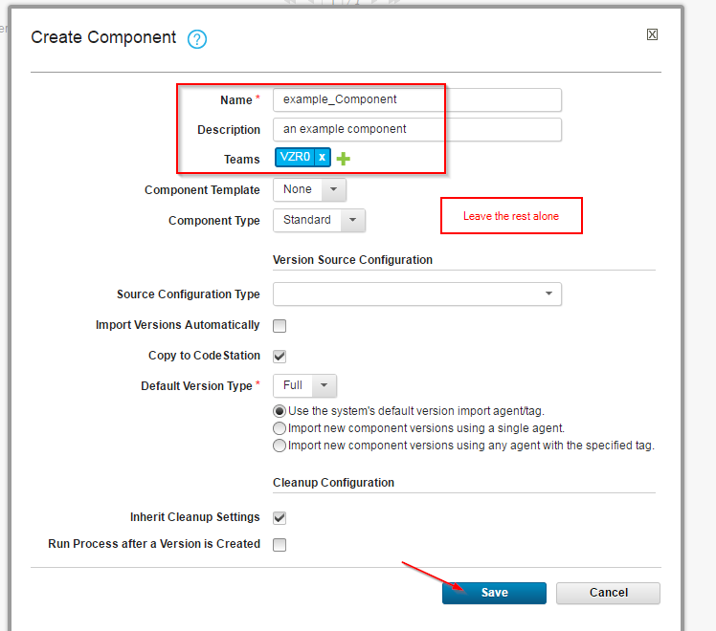

**2) In your new component, go to processes and build a deployment process**

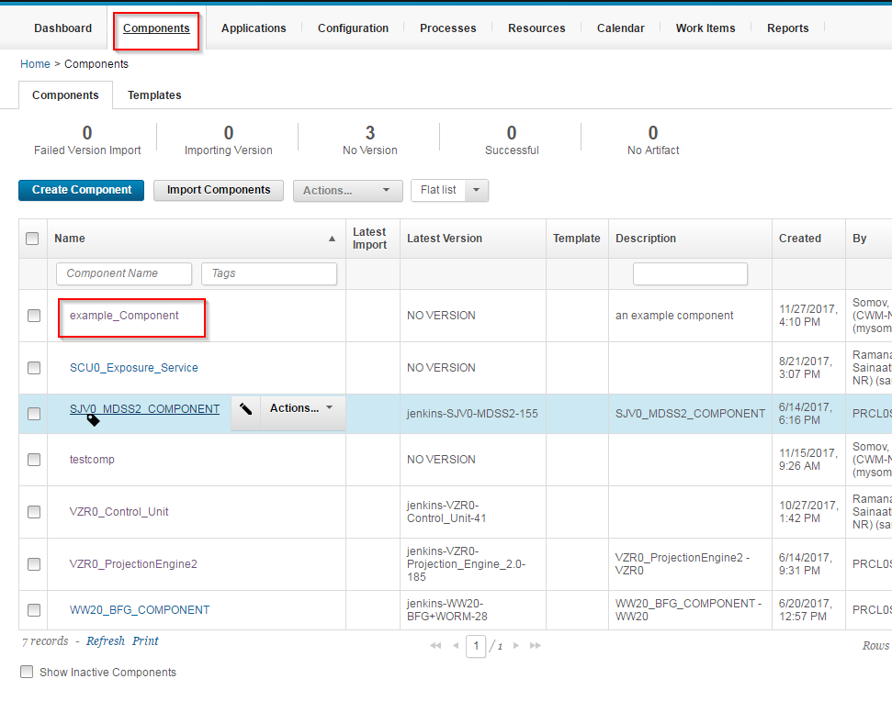

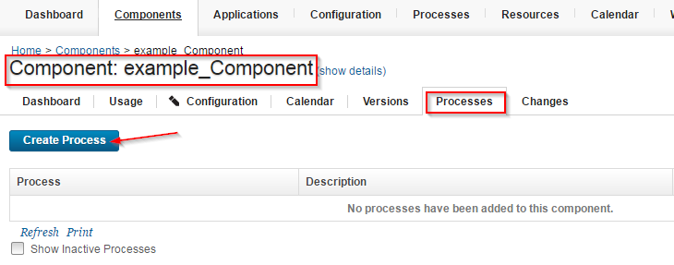

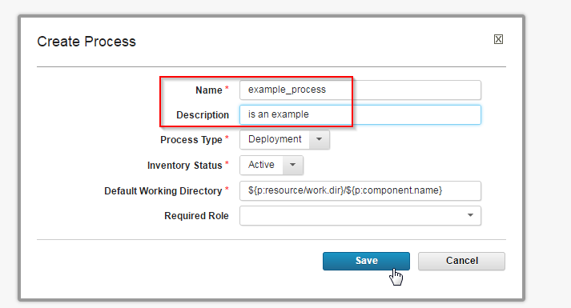

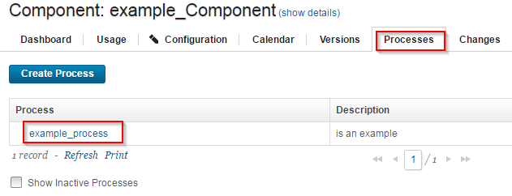

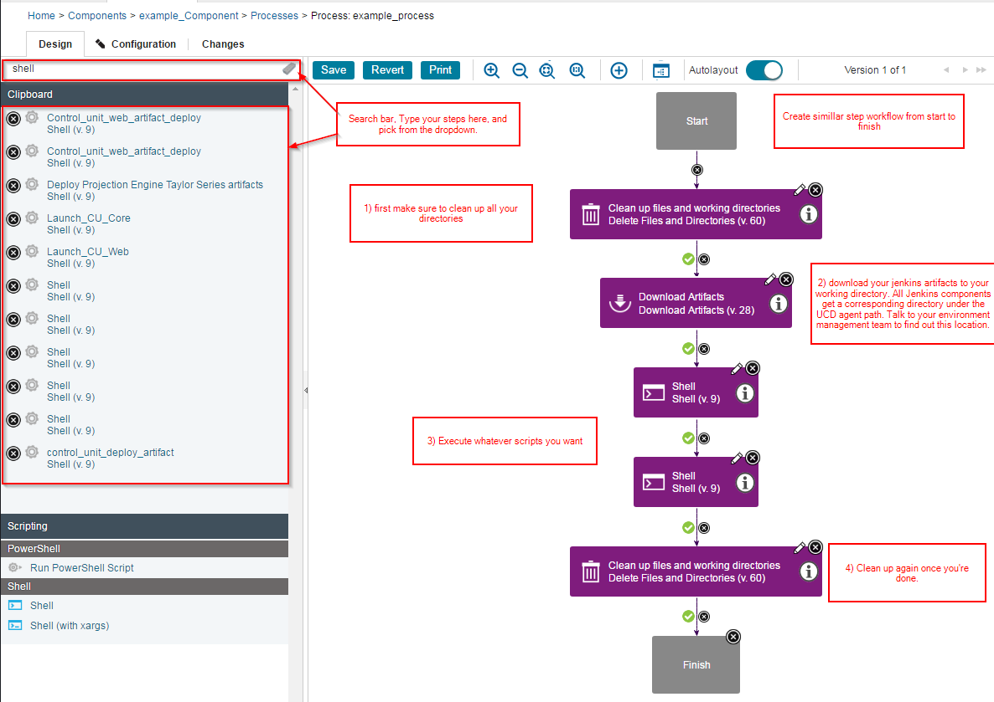

**3) Add component to your application**

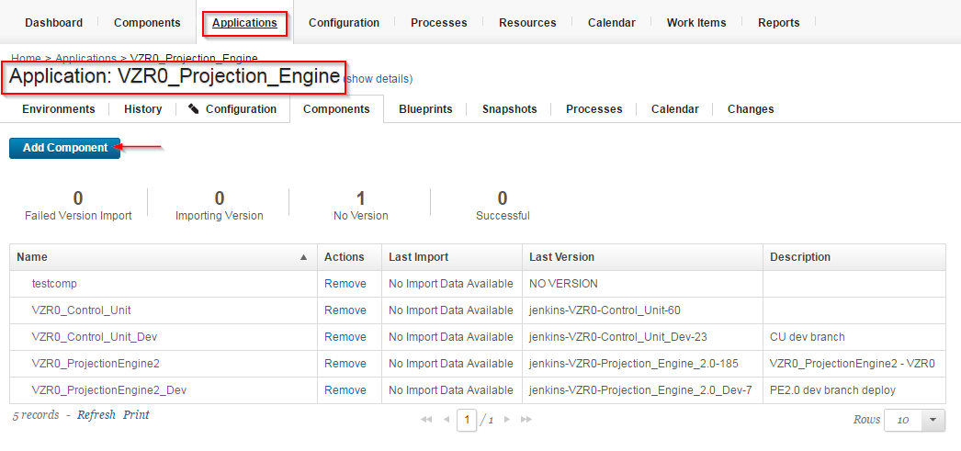

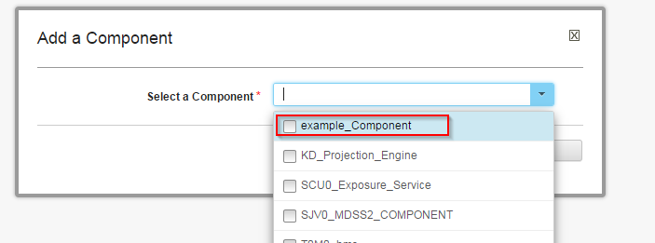

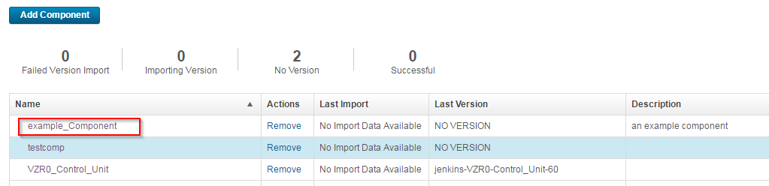

**4) Add a process to your application to install your component**

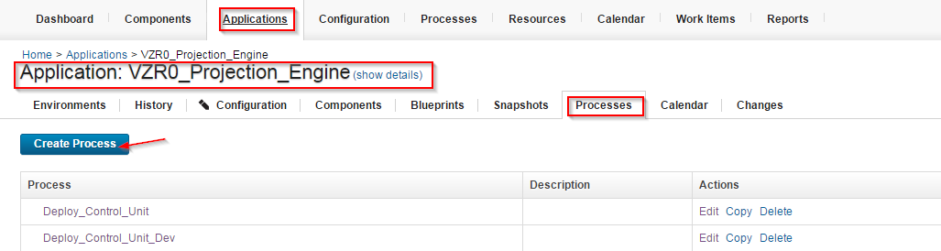

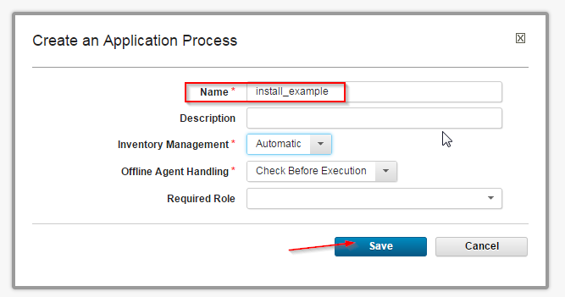

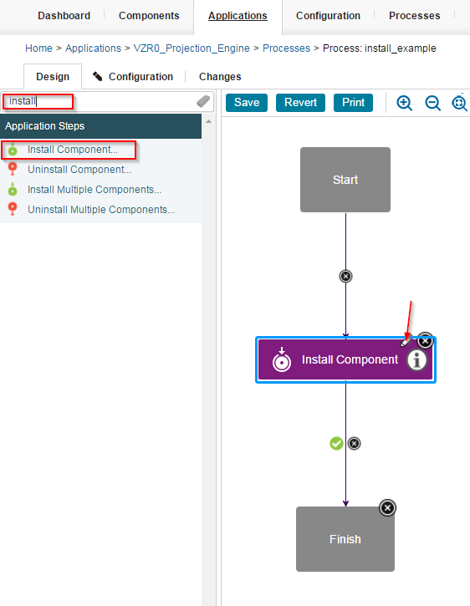

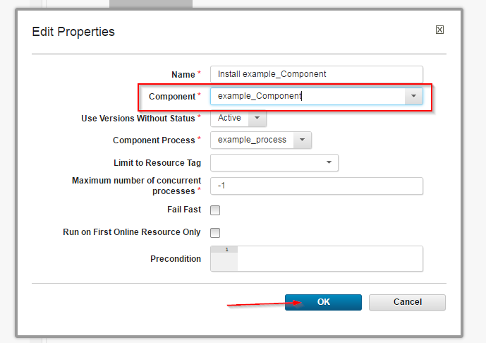

**5) Go to your application, and under all your target environments, add your component**

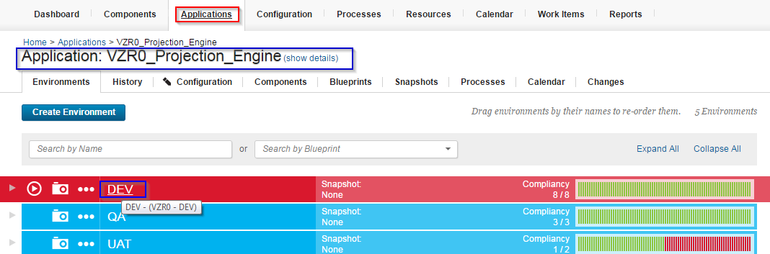

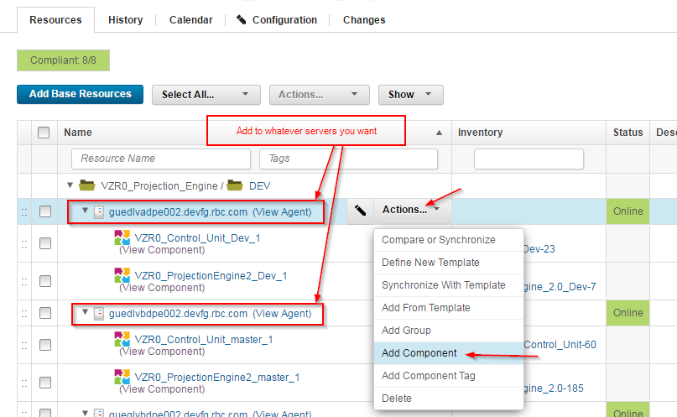

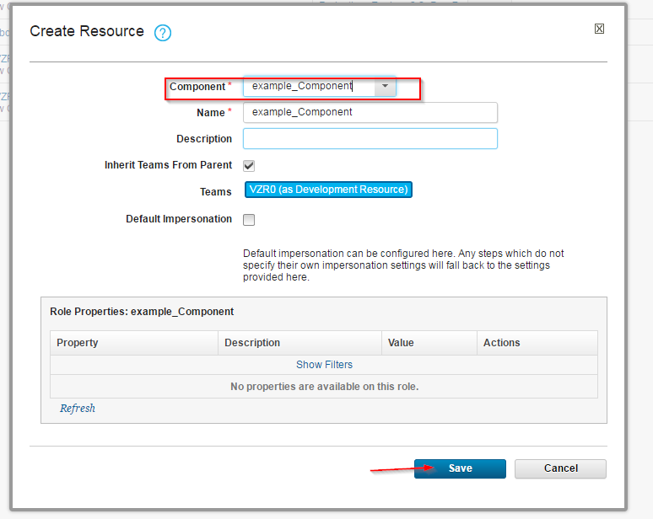

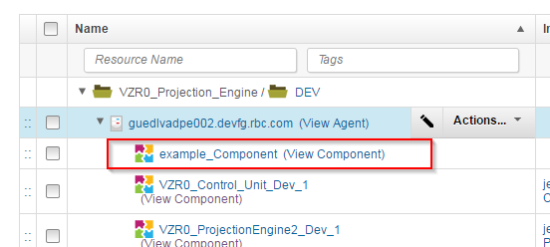

**6) Add a post build action to your Jenkins, to trigger your Component**

